Specific Focus | Task: Student Directions | Example
Step 1:  Logging On | Turn on a Chromebook  Do NOT log in  Click “Apps” in the bottom left  Select AIRSecureTest | 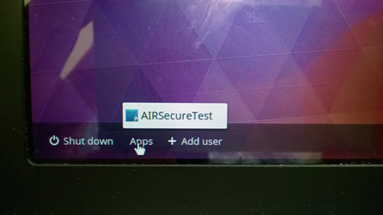
 | Click the link that says “Click here to go to the Practice and Training Test Site” | 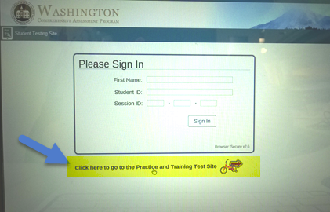
Step 2:  Assessment Options | Just click “Sign in” as a guest. | 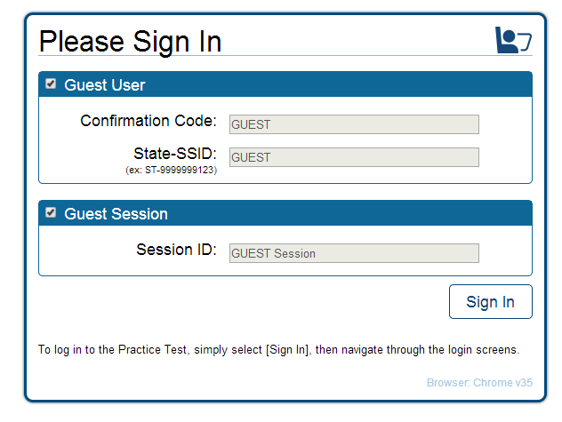
Step 3:  Grade level | Choose appropriate grade level.  Choose Yes. | 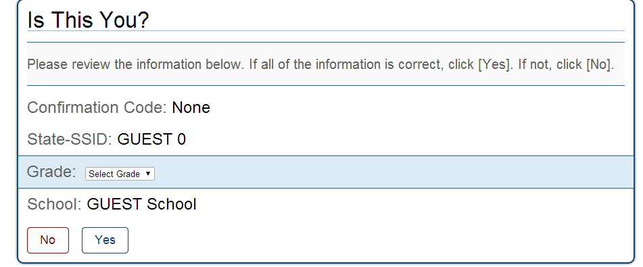
Step 4:  Student Options | Select “Start ELA Grade ___ Training Test.” | 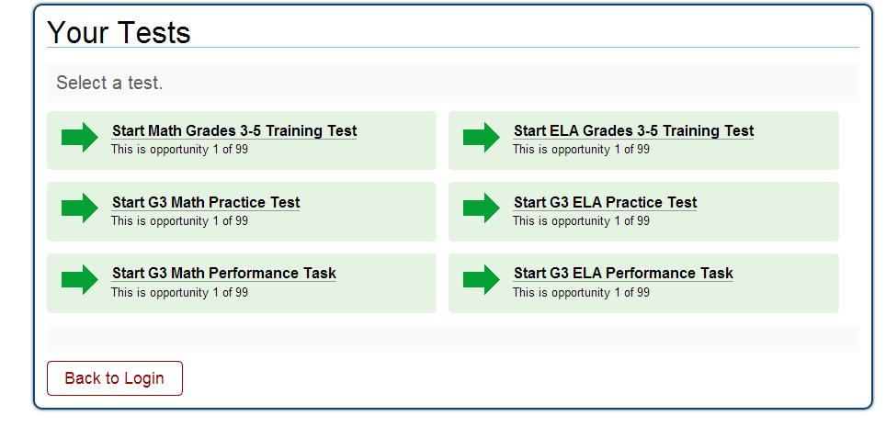
Step 5:  Choose appropriate Test | Only make changes to any settings, if you have “specific” student learning needs.  If you have specific learning accommodations, please ask your teacher for help on this screen. | 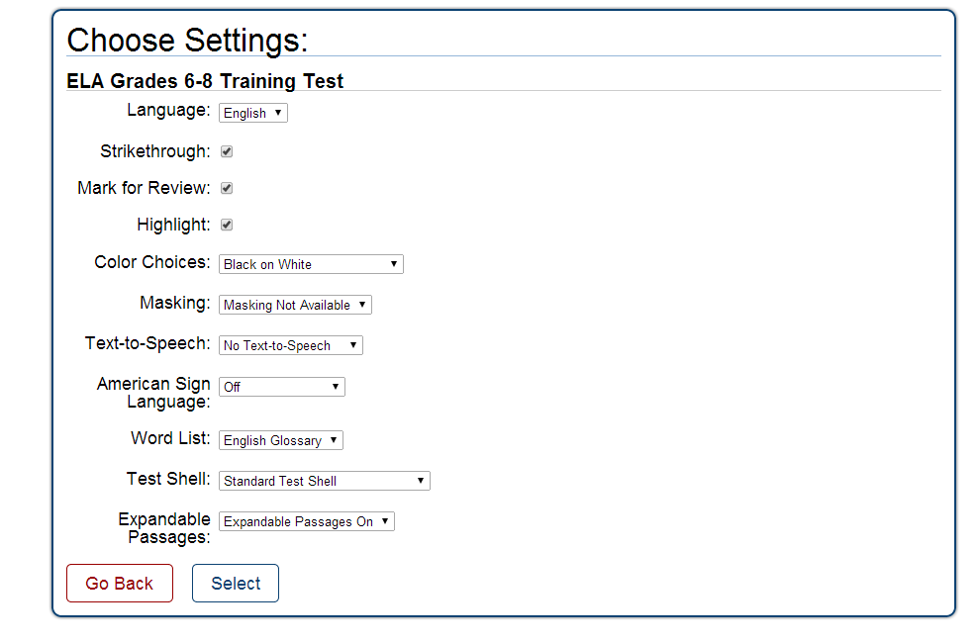
Step 6:  Start Test | Choose “Yes, Start My Test.” | 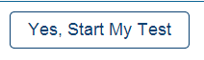
Step 7:  Sound Check | Plug your headphones into the “headphone icon” of your computer station.  Click the sound icon to “hear” the sound.  If you hear the sound, click “yes” and if not, check to be sure your headphones are plugged into the correct location of your computer.  You can adjust the sound on the Chromebooks using the volume keys on the upper right part of the keyboard | 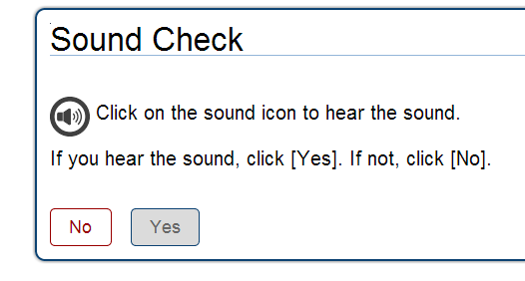  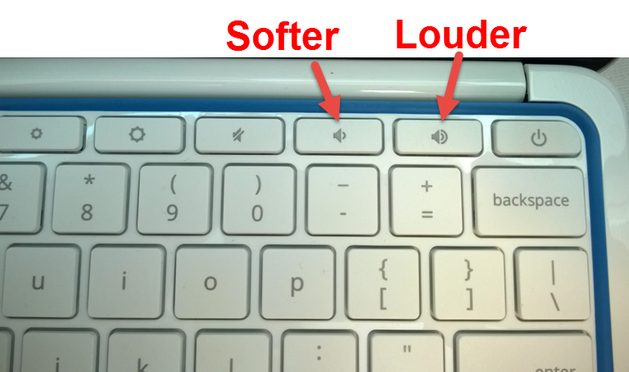
Step 8:  Begin “Overview of the Student Testing Site.” | Choose “Begin Test Now.” | 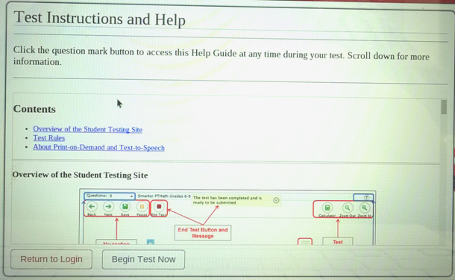
Step 9:  The assessment. | Please take the practice assessment, you will only have between 6-10 questions to work through.
Step 10:  Reflection | - Now that you have completed the practice assessment, reflect and respond to the questions in the next column: | - What strategies have you learned from your teachers to be successful on assessments?  - What would you mark in order to code the text?  - Good news, your next few lessons will teach how to use the “Universal tools” available on the SBAC assessment, so you can “Code the Text.”

